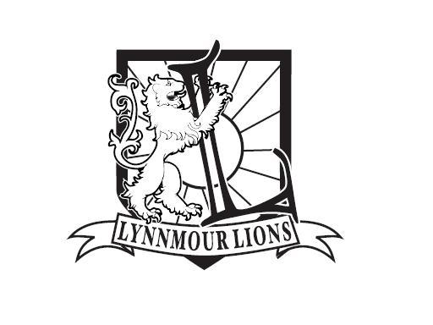

LYNNMOUR PARENT ADVISORY COUNCIL
ANNUAL REPORT 2016-17

In June 2016, a new PAC Executive was elected. After a year of hard work, we are happy to announce a wide variety of successes for the school year 2016/17.

We started the school year by welcoming all families back at a PAC-sponsored pizza dinner. In September we also prepared welcome-donuts and coffee for new Kindergarten parents.

Throughout the year we created many fundraising opportunities: three Cash 4 Clothes events, one bottle drive, two Fundscrip orders, and parents also had (and have) the opportunity to contribute by simply mentioning Lynnmour School when purchasing baked goods at Cobs Bakery at Park & Tilford and Parkgate. For Lynnmour students we offered monthly Snack Shacks and Booster Juices.

Our annual Christmas Market showed once again the tremendous amount of thought and love that the students put into purchasing Christmas gifts for the whole family, and it brought the Lynnmour community together again. With that in mind we introduced the Spring Fling at Seymour’s Pub, which was overwhelmingly well received.

The PAC is also happy to have once again sponsored bus trips to the pumpkin patch for Kindergarten students, school performances as well as lunch for the students at Fun Day. The Urban Safari Animal Rescue visit with their exotic animal presentation at the end of the school year was an additional treat for the students. We were further able to support each classroom, the library, music and LAC with financial contributions, and the school purchased a new sound system with our help. The Windsor student who received our bursary would like to pass on her thanks to the PAC as well. Lastly, we are also proud of having even been able to purchase new tables for next year’s grade 6/7 class.

Lynnmour PAC now has a website, a Facebook page and Twitter account. Our website received over 3000 page views with over 1000 unique sessions from September to present, and we have approximately 70 users of the website in any given month.

We would like to thank all parents, students and staff who have contributed their time and money to help our PAC and thus the school and students. We would especially like to thank our principal, Kelly LaRoue, without whose relentless efforts and most valuable advice we would not have been able to achieve any of our goals.

We will continue to do our best to bring the community together and help Lynnmour students to succeed in their learnings. We are looking forward to another successful school year 2017/18.

Karen Wonneberger – Chair
Roxanna Smallwood and Tara Rosadiuk – Co-Vice Chairs
Katie Pettit – Secretary
Al Young – Treasurer

